Renters Insurance is Important
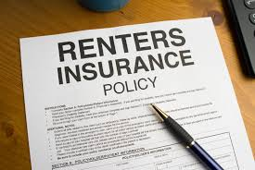

Unfortunately, things happen. Fires, theft, weather damage…, and they’re just as likely in a rented apartment as they are in a house. To protect themselves, Homeowners purchase homeowners insurance. But homeowners insurance doesn’t protect the renter. That’s were renters insurance comes in.
The main reason to purchase renters insurance have insurance is so that when these things happen, you don’t have to shoulder the entire cost on your own. The insurance company steps in and helps out, so the problem isn’t as disruptive to your life and livelihood as it would have been if you had not had that policy coverage in place.
Renters insurance is similar to Homeowners insurance except instead of protecting the property it protects the renters items inside the property.
Not only does it protect your personal property — like TVs, clothing, couches, computers — in case of a loss, but it also provides some liability protection in case the dog bites someone, you cause a flood to other units or a guest at the property gets hurt. Many policies even provide cash to cover temporary living costs and rent on another unit in case you cannot live in the apartment due to damages.
Lastly it is comparatively inexpensive compared to other coverage types. And if you add it to your other existing policies, like an Auto or Life insurance policy, you will receive even better rates.
That why when you rent from Amador Valley Property Management we require renters to purchase renters insurance policy

