Maintenance Responsibilities for Tenants
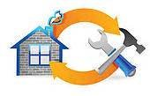
The responsibility of rental property maintenance belongs to both landlords and tenants. State and local laws require that tenants maintain rental properties at a habitable condition, meaning that homes should be kept clean with only reasonable wear and tear. As a tenant with Amador Valley Property Management, it is important that you have a good understanding of the responsibilities that are expected of you.
As a rental property tenant with Amador Valley Property Management, you are expected to respect the home you are leasing by maintaining reasonable care of the property. The property is your home for as long as you are living there, but it is important to remember that you are leasing a property that ultimately belongs to someone else.
As a tenant you are required to do the following: 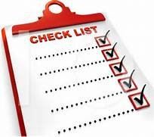
- Keep the property clean, orderly, and habitable
- Dispose of trash, waste, or debris in a clean, safe manner
- Water lawns, check sprinklers, and maintain landscape care
- Use all electrical, plumbing, sanitary, and heating/cooling systems properly
- Maintain upkeep of minor home maintenance issues such as changing light bulbs, replacing smoke alarm batteries, and replacing filters in heating or cooling systems
- Change smoke detector Batteries
- Replace A/C/Heater filters every 6 months
- Fix anything you break or damage
- Promptly notify landlords of defective or dangerous conditions that are out of your control such as appliance failure, animal infestations, malfunctioning heating/cooling systems, leaky roof, or cracked foundations

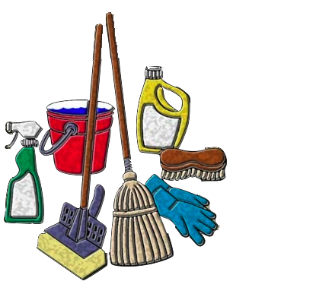
Cleanliness
Tenants should maintain the home in a reasonably clean and habitable state. A habitable state is one in which the property is suitable to live in. Responsible tenants will keep the property free from large amount of filth both inside and outside of the home. To maintain cleanliness, Amador Valley Property Management Services recommends that tenants of their rental properties do the following:

- Maintain reasonable housekeeping
- Take care to dispose of trash properly
- Clean spills and stains that could damage carpeting, flooring, or other parts of the home
- Stay on top of lawn care, weed removal, check that the sprinklers are working, and yard debris
- If you have a pet, clean the yard, and pick up their poop regularly
- Do not leave food, (Pet or Human) lying around the house or yard as it will attract unwanted pests

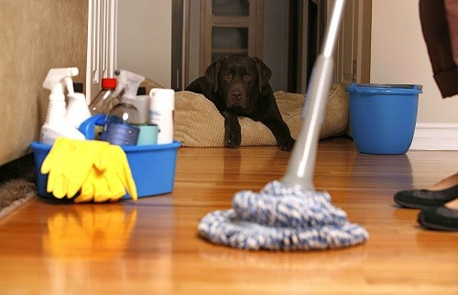
House Cleaning Service at Amador

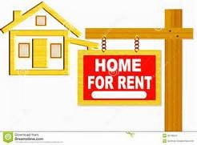
Repairs
Amador Valley Property Management Services does require property owners to carry the responsibility of major repairs that are out of a tenant’s control, but it is the tenant’s responsibility to make any repairs caused by their own doing. For example, a property owner is responsible for damage to the sewer system cause by a large tree root. A property owner is also responsible for replacing an older appliance that stops working. However, it would be the tenant’s responsibility to cover the charge for a plumber if the toilet floods from their child flushing a toy down the toilet. Likewise, it would be the tenant’s responsibility to pay for the repair of damage to an appliance caused by his or her own carelessness
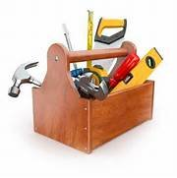
House Repair Service in Amador
In order for property owners to provide the proper maintenance required of them, tenants will also be held responsible for reporting necessary repairs. By reporting repairs as they present themselves, further damage can be avoided. When there is not accurate and timely communication between property owners and tenants, it becomes difficult to determine who is responsible for the cost of correcting the problem.
The key to clearly understanding what is expected of you as a tenant is to openly communicate with Amador Valley Property Management and the property owners. If needed, ask that maintenance responsibilities be clearly outlined and do not shy away from asking questions. The better informed you are, the more aware you will be of your responsibility as a tenant.

